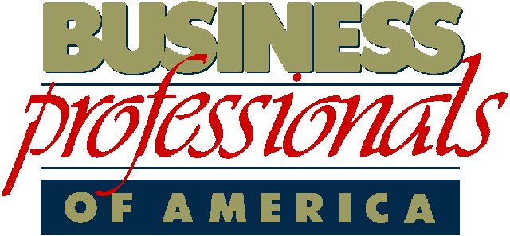
Pop Quiz
Mr. Guyer E-102
Fundamentals of Technology

Name_________

Class Hour_____

Directions: Please choose the best answer possible. Better to guess than not to answer at all. Use yellow highlighter to answer all questions.

- S.L.A.N.T. stands for what?

- Sit-Down, Listen, Ask Questions, Kneel, Tall
- Sit-up, Listen, Ask Questions, Nod your Head, Track the Speaker
- Step it up, Look around, Always talk, Never sit, Trick students
- All of the Above

- Food & Drinks are allowed in class? A) True B) False

- This computer class is a Career Tech class, and Mr. Guyer is a Career Tech teacher.
- True B) False

- What is the name of the club that is attached to this class?

- FCCLA
- DECA
- DRAMA
- BPA

- If you join BPA, how much are the dues?

- $50
- $35
- $25
- Zero its free

- Business Professionals of America (BPA) is a club that focuses on business and networking so students have a higher chance of getting jobs and developing their skills.
A) True B) False

- MHS is what kind of school this year?

- BYOD B) Uniform School C) Non-Sports D) All of the Above

- B.Y.O.D stands for what?

- Bring Your Own Dog
- Bring Your Own Devices
- Bring Your Own Dirt
- None of the Above
- Students are never allowed to play games on the computer because it gives a bad perception of our class when someone walks by?

- True B) False

- Students are allowed to play games on the iPad at designated times at their desk.
A) True B) False

- There is a class rubric that helps students determine their own grade in this class.

- True B) False

- If a student SLANTS in class when Mr. Guyer says to SLANT, those students receives a grade in the grade book.

- True B) False

- This class requires all students to have an online portfolio as part of their grade and Career Tech requirement.

- True B) False

- The student portfolio we use in class is called Weebly. A) True B) False

- Students no longer have a physical handbook, but rather an online version.

- True B) False

- MHS students are expected to abide by what standard this year?

- Anything goes
- Teacher Commandments
- 5 Commandments for Every Student
- None of the Above

- Identify two of the student commandments.

- Bravery & Toughness
- Bullying & Bad Language
- Keep it Clean & Respect others
- All of the Above

- All Career Tech students must take a safety exam in class.

- True B) False

- Making fun of someone’s learning ability is a form of bullying and will not be tolerated?

- True B) False

- Our class has a seating chart? SA) Yes B) No

