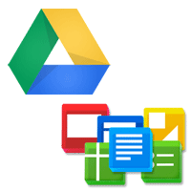
Google Docs/Drive
Chapter 1
“All about Google Drive and Docs”

Directions: Click on the above Hyperlink to access your online textbook
And complete the worksheet.

- Google Drive is a free service from Google that allows you to store files from your computer online and access them anywhere using the Cloud.

- Google Drive also gives you access to one of Google's most popular services, Google Docs.

- Google Docs is a free, web-based application for creating documents, spreadsheets, and more. In this lesson, you'll learn more about Google Drive and Google Docs and how the cloud can help you in your everyday life.

- Google Drive, a cloud-based storage system that allows you to keep your documents, photos, videos, and other files online. Whenever you place files on Google Drive, they are stored on internet servers servers rather than your computer's hard drive.

- You can then access those files from any computer with an internet connection or even a mobile device, like a tablet or smartphone. Drive even allows you to share files with your family, friends and co-workers.

- Google Drive is one of the most advanced cloud storage services available today, offering five gigabytes (5 GB) of free storage space.

- List the five (5) types of docs you can create and share with Google Docs

- Documents B) spreadsheets C) presentations D) forms E)drawings

